SSQL Computer Skills Tutorials

Table of contents

Introduction 2

1. Environment Setup 3

2. Organization within a Document 7

3. File Management 11

4. Mouse/Trackpad Skills 19

5. Keyboard Skills 21

Author: Ella Foster-Molina

# Introduction

These tutorials focus on efficiency with your [mouse/trackpad](https://swat-ssql.github.io/computer-skills-tutorials/mouse_trackpad.html), [keyboard shortcuts](https://swat-ssql.github.io/computer-skills-tutorials/keyboard.html), [file structures](https://swat-ssql.github.io/computer-skills-tutorials/file_management.html), [organizing a Word document or Google Doc](https://swat-ssql.github.io/computer-skills-tutorials/doc_nav.html), and your overall [computing environment](https://swat-ssql.github.io/computer-skills-tutorials/environment_setup.html). They are designed primarily for college students. Readers should know how to touch type, use text editors or word processors like Google Docs or Microsoft Word, and have a basic idea of how to download files.

## Choose your approach

This document has the same content as the [online version](https://swat-ssql.github.io/computer-skills-tutorials/) but a different organization. Like the online version, it can be completed in a variety of ways. Here are suggested options:

Option 1: Complete each section independently.

Option 2: Start at the beginning, “Environment Setup,” and work your way through.

* + “File Management” and “Environment Setup” provide the biggest efficiency gains. They also take longer to complete and are designed for the sophisticated file systems and flexible environments of PCs and Macs.

Option 3: Start with “Keyboard Skills” and “Mouse/Trackpad Skills”. These are short and will provide the quickest gains in efficiency for most users. These sections and “Organization within a Document” can be completed on a tablet or computer.

Option 4: Complete the [Computer Skills Assessment](https://swat-ssql.github.io/computer-skills-assessment/) now, later, or in parts. Just like these tutorials, the assessment is modular. If you are familiar with the skills and simply want a quick self-assessment, skip these tutorials and head to the assessment.

## Know the skills and practice them

Each section below is divided into skill and practice subsections. Just like learning the piano, computing requires knowing the skills. It also requires applying the skills through practice. You can train your fingers to dance over the computer keyboard like a pianist's fingers dance over piano keys.

Skills: Gain knowledge of core computing skills by working through the tutorials. You can also Google topics such as “[computer shortcuts,](https://letmegooglethat.com/?q=computer+shortcuts)” “[file management,](https://letmegooglethat.com/?q=file+management)” and “[navigation pane](https://letmegooglethat.com/?q=navigation+pane)” to find additional tips and tricks.

Practice: Incorporate these skills every time you use your computer, including while you read through this document. Practice the skills in the “Practice” section at the end of each skill tutorial. In some cases, practice them repeatedly. Play the computer games Minesweeper or Solitaire. Computer developers originally made these games available on the computer to incentivize users to learn key mouse/trackpad skills.

## Assess your skills

Assess your skills by completing the Computer Skills Assessment [online](https://swat-ssql.github.io/computer-skills-assessment/) or [downloaded as a Word document](https://github.com/swat-ssql/computer-skills-assessment-docx/raw/refs/heads/main/Computer-Skills-Assessment.docx). If you cannot complete the tasks in the assessment, do not fret. Simply come back to these tutorials, practice, and return to the assessment later.

# 1. Environment Setup

This section overviews some useful modifications to your general computing environment. It is designed for a Mac or PC computer, not a tablet or phone.

All sections of this tutorial, including this one, are designed to be completed independently. Since portions of the skills in this section are required for the other sections, pieces of these skills will also be shown in subsequent sections. You can simply skip over those skill explanations in subsequent sections if you start here.

## 1.1 Skills

The default settings on many programs focus on the most common use cases, not more advanced uses. All of these settings can be quickly modified. For example, you can:

* show the path for your files by default,
* make a Mac’s mouse/trackpad secondary-click button easier to access, and
* show the navigation pane for Word and Google Documents by default.

### Window management

It is often helpful to arrange your application windows so that two or more are readily visible on the same screen. This lets you see the origin of your information at the same time as you see the new location for your information. When information is visible at both its origin and destination, you can copy-paste and drag-drop that information more efficiently than also having to recall and re-order windows. This can help:

* manage files and folders,
* copy and paste information from a browser into a Google Doc/Word document, and
* simultaneously view tutorials and apply the skills in real time.

This may take some practice to apply quickly and effectively.

Note that some computer users take this to an extra level. They use two or more computer screens to enhance the amount of information displayed and available for organizing. For example, I currently have the Word version of this document open, along with the Computer Skills Assessment, a set of notes from a workshop on computer skills, and an application to edit the screen grabs included in this document. These documents are organized across two screens for easy access to information.

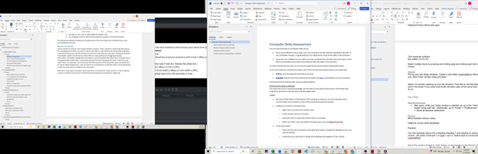

### Path bars

A path bar is a navigational tool in file management applications that shows your location in a file system by displaying your current visible folder and the folders it is nested within.

The path bar has many uses. You can:

* see where your files are located at all times,
* copy the location of your files in text form, and
* navigate up your folder tree by clicking on higher level folders in the path bar.

On a Mac in the Finder application, the path bar is hidden by default. You can change this default by opening Finder and clicking View -> Show Path Bar in the Finder menu options. The path will appear at the bottom of the Finder application window. Navigate your folder structure by clicking on folders in the path bar. Copy the path address by right (secondary click) clicking on the path and selecting “Copy path.”

On a PC, the path bar is always visible in the upper portion of the File Explorer application. Navigate your folder structure by clicking on folders in the path bar. Copy the path address by clicking into the blank white space next to the path bar and pressing Ctrl+c.

|  |  |
| --- | --- |
| Mac  Mac | PC  PC |

Additional information on organizing your files is in “File Management” > “File Structure”.

### Mouse/trackpad settings

* Search for your mouse/trackpad settings by searching for “Mouse Settings” in your spotlight search on a Mac (press Command + space bar) and the search bar (bottom left) on File Explorer and see if you want to adjust any settings.
* On a Mac, mice/trackpads may not have easy access to a right (secondary) click. You can access the secondary click menu by pressing Ctrl+click at any time, but this is inefficient. For a more accessible right click, adjust your mouse settings or install a third-party app such as BetterTouchTool.

### Word processor setup: the navigation pane

When working with a text-based document or note that has more than a page of text, document organization can help. Document headers provide many organizational benefits, including:

* idea organization,
* document navigation by clicking on the relevant part of the outline in the side panel,
* interactive tables of contents,
* document accessibility, and
* facilitate teamwork and delegation.

In **Microsoft Word,** you can see a navigation pane with all headers, which creates an interactive table of contents. To access the navigation pane, go to the View ribbon. In the “Show” section, click “Navigation Pane.” Make sure you are in the Document Map (Mac) or Headings (PC) section of the panel on the left.

**Google Docs** opens the navigation pane by default. You may need to click the list icon at the top left of your screen.

|  |  |
| --- | --- |
| Microsoft Word (PC)  Microsoft Word (PC)  Microsoft Word (Mac)  Microsoft Word (Mac) | Google Docs  Google Docs |

## 1.2 Practice

Tasks:

1. Make sure this tutorial is saved in a logical place on your computer or a cloud environment. Logical in this context means a place that you could reasonably and quickly locate if you forgot the actual location of the document. The section on “File Structure” under “File Management” may be helpful.
2. This document should be open in Google Docs or Microsoft Word. If you are comfortable with a specialized text editor, feel free to use that instead. All sections other than “Organization within a Document” are possible in specialized text editors.
3. Save a copy of this document with the current date at the end. For example, it could be “Computer Skills Tutorials 2025-06-17.docx”.
4. Ensure that the navigation pane is open and visible on the left side of the screen.
5. The document you saved starts with this section. Start working through the next sections!

# 2. Organization within a Document

A heading in writing is a title or subtitle used to introduce and organize sections of text, making the text easier to understand. It acts as a signpost for the author and reader to guide them through the narrative. You can find an expanded guide [here](https://swat-ssql.github.io/organization-within-document).

Many text editors can turn headers into an interactive navigational pane, which doubles as a table of contents. This provides various organizational benefits, including:

* idea organization,
* document navigation by clicking on the relevant section in the side panel,
* interactive tables of contents,
* document accessibility, and
* facilitating teamwork and delegation.

You can readily make headings with a few keystrokes in Google Docs or Microsoft Word. Put your cursor blinking on some text then press Ctrl+Alt+(number) on a PC or Cmd+Option+(number) on a Mac. Read on for details on how and when to use headings.

### Example heading use cases

These are some examples of how headers can help.

1. Jump around this document to work on individual sections.
2. Use headers to organize notes on a (hypothetical) American Wars course by date. At a glance, you can jump from your class on October 6th on the WWI to your class on November 3rd on the Vietnam War.
3. You can jump from the introduction to conclusion in a research paper with a click. This can help ensure that both sections are argumentatively aligned.
4. In Microsoft Word, you can collapse all sections of your document to focus on the one or two that you are currently working on. 
5. You can send a link to a particular section (Google Docs), create hyperlinks within the text to specific sections (Google Docs and Word), or tell a collaborator to look at section “XXX” and use the navigation pane to get there (Google Docs and Word).
6. You can “zoom out” of a long document with headings by looking at the navigation pane. With this view, you can assess questions like “Does this order make sense?”

Most other advanced text editors have their own methods of creating document headers for navigation. This document focuses on two basic word processors: Microsoft Word and Google Docs. Note that Microsoft Word is often the industry standard as a word processor. Google Docs makes sharing easier but is not as fully featured as Microsoft Word.

## 2.1 Skills

### Enable the navigation pane

The navigation pane displays all headings in your document in an easy-to-use and ordered way. To see the navigation pane in Microsoft Word, go to the View ribbon. In the “Show” section, click “Navigation Pane.” Google Docs opens the navigation pane by default. You may need to click the list icon at the top left of your screen.

|  |  |
| --- | --- |
| Microsoft Word  Microsoft Word | Google Docs  Google Docs |

### Heading structure

Decide what level of heading you want to apply. If it’s a first order topical heading like “Organization within a Document” above, that is a level 1 heading. If it’s a second order heading like “Keyboard method to create headings” below, that is a level 2 heading.

### Keyboard method to create headings

Headings are especially practical if you memorize the keystrokes to generate them.

|  |  |  |  |  |
| --- | --- | --- | --- | --- |
| **Type** | **Microsoft Word**  **(PC)** | **Google Docs**  **(PC)** | **Microsoft Word**  **(Mac)** | **Google Docs**  **(Mac)** |
| Heading level 1 | Ctrl+alt+1 | Ctrl+alt+1 | Cmd+option+1 | Cmd+option+1 |
| Heading level 2 | Ctrl+alt+2 | Ctrl+alt+2 | Cmd+option+2 | Cmd+option+2 |
| Heading level 3 | Ctrl+alt+3 | Ctrl+alt+3 | Cmd+option+3 | Cmd+option+3 |
| Normal | Ctrl+shift+n | Ctrl+alt+0 | Cmd+shift+n | Cmd+option+0 |
| Heading dialogue box | Ctrl+shift+s |  | (see text below) |  |

Note that Google Docs can create additional heading levels beyond level 3 using the same keyboard shortcut pattern. Microsoft Word stops keyboard shortcuts after heading level 3, although Ctrl+shift+s (PC) provides a handy alternative for lower-level headings. A more complex solution for a Mac can be found by Googling “[mac apply styles shortcut word](https://www.google.com/search?q=mac+apply+styles+shortcut+word).”

Sometimes you might need to change multiple headers from UPPER CASE to Title Case or lower case. A handy trick in Microsoft Word is to change the case pattern of text using shift+f3 (PC) and Cmd+shift+a (Mac). Put your cursor in the middle of the word you want to change, then press the keyboard combination above.

### Change format of all headers

On either platform, you can adjust heading formats easily with the following steps:

1. Move to one of the existing headers in this document, such as “Change format of all headers”. Change the format; you can bold it, for example. Keep your cursor blinking on that header.
2. To make all headers with that level match your new format
   1. Microsoft Word: Select the “Home” ribbon. In the “Style” section, right click on the appropriate header. Click “Update Header to Match Selection.”
   2. Google Docs: Click into the heading section of the ribbon. Move your cursor to the appropriate heading. Click “Update Heading __ to match.”
3. All headings of that level should now match the format of the heading your cursor started on.

|  |  |
| --- | --- |
| Microsoft Word  Microsoft Word | Google Docs  Google Docs |

## 2.2 Practice

Tasks:

1. Make the “Tasks” line above into heading level 3 with just your keyboard.
2. Change the format of the “Tasks” line.
3. Apply that format to all level 3 headings in the document.
4. Undo your changes with just your keyboard.

The following gif shows an example of these tasks in Microsoft Word.



# 3. File Management

File management on a computer refers to the processes and techniques used to organize, store, retrieve, and manage digital files. Ideally, this is done using a structured system that facilitates retrieval, because we all inevitably forget where something is.

The developers of modern computers have gradually added barriers to creating useful file structures on a computer. Yet file management is critical to:

* consistently retrieve files,
* organize ideas,
* store and organize multiple documents associated with a single project,
* create a unique internal address that pinpoints the location of a file or folder,
* effectively code, and
* manage complex research projects.

File management is almost entirely inaccessible on most tablets and smartphones. It is readily possible on a computer but requires a few additional clicks and environment adjustments. As such, this section is designed for a Mac or PC computer, not a tablet. Similar principles apply to a Chromebook but are not demonstrated here.

File tags provide additional organization. They should be used as secondary file organization tools and not primary organization tools like a file structure. The file structure creates a unique internal address for a file that is quite useful for advanced computing.

## 3.1 Skills

### Path bars

A path bar is a navigational tool in file management applications that helps you keep track of where you are in a file system. It displays your current visible folder and the folders it is nested within. It allows you to copy the address of your file in text form. It also lets you navigate up your folder tree by clicking on higher level folders in the path bar. It is useful in many contexts, and critical for coding projects. Alternate methods exist for each of these tasks, but the path bar accomplishes all of them and is similar on Macs and PCs.

#### PC

The path bar is always visible in Window’s File Explorer. To access the text version of the path, click into the blank white space next to the path bar.

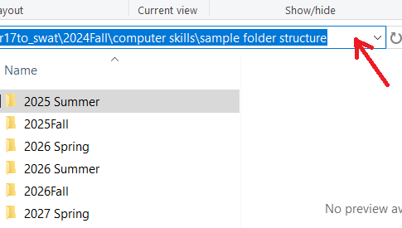

#### Mac

The path bar on a Mac is hidden by default but can be displayed by clicking View > Show Path Bar in the Finder menu options. The path will appear at the bottom of the screen. The path can be copied by right clicking on the path at the bottom of the screen and selecting “Copy path”.

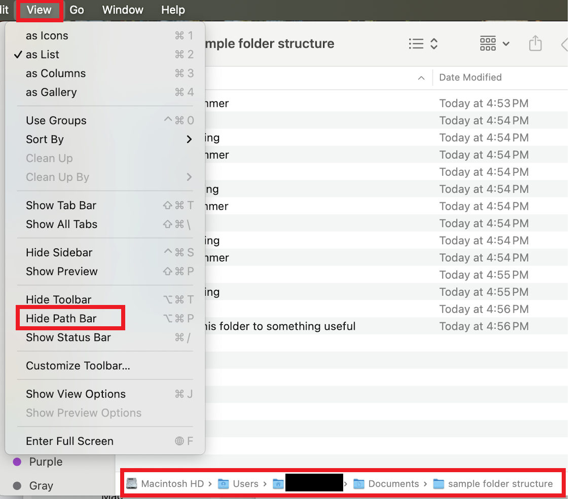

#### Google Drive’s path, of a sort

Google Drive also has a folder structure, but it is not nearly as useful or accessible as Mac’s Finder or Window’s File Explorer. It is difficult to copy the path address (as of Summer 2025). That said, the path does appear at the top of your Google Drive screen. You may need to click three little dots to the left of the path to access the full path information.

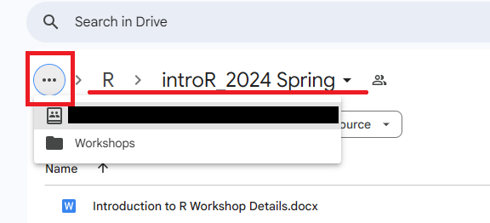

### File structure

A file structure is how you organize and store your files and folders for easy access and management of files.

#### The Documents folder

On a Mac and PC, you should default to creating a file structure in the “Documents” folder. This is the location intended for permanent file storage for most users. Instructions for alternatives, such as setting up a synced Google Drive, can be found on [Google](https://www.google.com/search?q=synced+Google+Drive+or+dropbox).

Note that your Downloads folder is intended for temporary storage. Many of the files you download, such as installers, are intended to be temporary files. Yet they can take up a lot of space. As such, good computer hygiene involves moving needed files out of your Downloads folder and then deleting the contents of your Downloads folder on a regular basis. This makes your Downloads folder uniquely unsuitable for permanent storage.

#### Clean out the Downloads folder

If you store your files in your Downloads folder, you do not have to fix it all at once. Instead, create a plausible file structure in your Documents folder, as described below. Move all contents of your Downloads folder to a folder named “Downloads (insert date)” inside your Documents folder. For all future downloads of potentially permanent files, save them in your Documents folder in a reasonable location. Over time, you can remove things from the copied Downloads folder titled “Downloads (insert date)” that now lives in your Documents folder. Delete unneeded files. Move others to reasonable locations in your Documents folder. Remove temptation to use your Downloads folder as permanent storage by regularly deleting all the files that end up there. The files in the downloads folder should all be temporary anyways.

#### Folder system organization principles

* Human brains track time-based categories well. When topics are nicely confined inside a time frame, contain them in folders devoted to a year, season, or semester.
* Human brains also track project-based categories well. You can organize folders devoted to particular parts of projects.
* Leverage the alpha-numeric ordering required by the Finder (Mac)/File Explorer (PC) programs.
  + Start file and folder names with the year when applicable. Add the month and/or day after the year.
  + Use spaces and punctuation strategically. “2026 Summer” is before “2026Fall”, because a space “ ” comes before “F” in the alpha-numeric order.
  + Start commonly used files and folders with the beginning of the alphabet. Even putting “1” or “aa” at the beginning of a file or folder can be effective, albeit inelegant.
* Balance the depth of your folders (how many folders are nested within each other) and the breadth of your folders (how many folders are within one single folder). Too deep, and you will spend too much time clicking into folders. Too broad, and you will have a hard time finding the folder you want. One suggestion is to keep your regularly/recently used files broad. Bucket older/less used files into a few folders.
* Google “[computer file structure principles](https://letmegooglethat.com/?q=computer+file+structure+principles)” to find more information about file structure systems.

#### Example folder system

The following is an example of a folder system that has been used successfully by many students and faculty. You can download this example at this link: [sample folder structure](https://github.com/swat-ssql/sample-folder-structure/raw/refs/heads/main/sample%20folder%20structure.zip). Change the years to fit your situation. Adjust semester to quarters or any other subdivision as needed. Select the folder and press “F2” on a PC and “Enter” on a Mac to rename the folder.

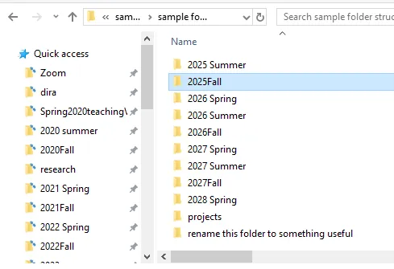

### Quick access/Favorites

Drag and drop regularly used folders into your “Quick Access” (PC) or “Favorites” (Mac) panel on the left side of your Finder (Mac)/File Explorer (PC).

|  |  |
| --- | --- |
| Mac  Mac | PC  PC |

### Window management

Window management refers to how the user places program windows on their screen. A user might have two windows side-by-side on their screen or look at one window at a time.

Looking at one window at a time and then swiping between windows or using keyboard shortcuts to navigate between windows can be useful for consuming information. For managing information, it can be helpful to show the original location at the same time as a location with new organization.

For files and folders, this means displaying a file’s origin window at the same time as you see the destination window. When you have both windows up, you can more efficiently move and organize files and folders than when you have to search and find windows before dragging and dropping files. For example, with the window configuration below, I can rapidly drag and drop the “Computer Skills” folder into my “all workshops” folder.

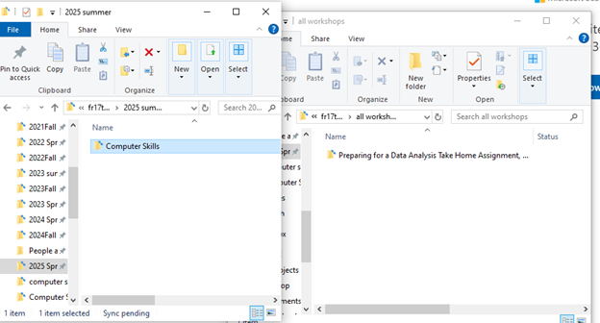

### Saving files in Microsoft Office

Microsoft Office hides the file structure by default when you save a document to simplify the interface. When you save a document (Save or Save As), the first screen tries to guess where you want to save it. If you have a clear file structure, its guess should only be accurate if you were working in the same location repetitively. This section shows how to access your file structure via the Browse button (PC) or a downward facing button (Mac).

To change the setting permanently, Google “[customize the save experience in office](https://letmegooglethat.com/?q=customize+the+save+experience+in+office)”.

Your screen may look slightly different than what is shown here. If it is too different to interpret, Google “[Browse file structure from save word](https://letmegooglethat.com/?q=Browse+file+structure+from+save+word)” to find a guide suited to your computer’s environment.

#### PC

On a PC, click “Browse” from the “Save” or “Save As” screen. In the resulting File Explorer window, browse to the appropriate folder and click “Save”.

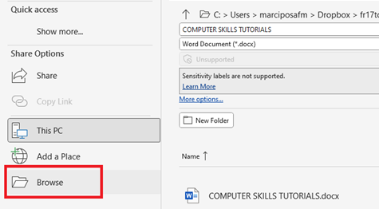

#### Mac

On a Mac, click the downward facing arrow next to “Where” from the “Save” or “Save As” screen. In the resulting Finder window, browse to the appropriate folder and click “Save”.

|  |  |
| --- | --- |
|  |  |

### Keyboard commands to navigate the Finder/Folder Explorer windows

|  |  |  |  |
| --- | --- | --- | --- |
| **Shortcut type** | **Key combo (PC)** | **Key combo (Mac)** | **Action** |
| *Moving between screens/windows* | Alt+`  (on some PCs) | Cmd+` | Move forward between Finder (Mac)/File Explorer (PC) windows |
|  | Alt +shift+` | Cmd+shift+` | Move backward between Finder (Mac)/File Explorer (PC) windows |
|  |  | Cmd+tab | Switch between open applications. The most recently used window of that application will be brought to the front. |
|  |  | Cmd+shift+tab | Move backwards between open applications. |
| *Navigate folders within Finder (Mac)/File Explorer (PC) windows* | Ctrl+n | Cmd+n | Open a new Finder (Mac)/File Explorer (PC) window |
|  | Ctrl+shift+n | Cmd+shift+n | Create a new folder |
|  | Two mouse clicks, too slow to be mistaken for a double click | Two mouse clicks, too slow to be mistaken for a double click | Rename the folder (this is a mouse action, but it is important enough to include here) |
|  | Select the folder, press F2 | Select the folder, press enter/return | Rename the folder |
|  | Ctrl+a | Cmd+a | Highlight all folders |
|  |  | Cmd+t | Create a new tab within a window |
|  | Delete | Cmd+delete (the one next to your +/= sign) | Delete a folder |
|  | Shift+arrow | Shift+arrow | Highlight multiple folders |

## 3.2 Practice

Tasks:

1. If you are on a Mac, set up your Finder window so that the path bar is visible at the bottom of the window. If you are on a PC, skip this step.
2. Set up and/or clean up your file structure. This could take a substantial amount of time. I recommend spending 10 minutes now to set up the general organization structure. Then schedule an hour in the next week to make progress on your organization. If you store files in your Downloads folder, pay particular attention to the section on cleaning out the Downloads folder.
3. Open a Finder (Mac)/File Explorer (PC) window. Arrange it so you can see these instructions and your Finder (Mac)/File Explorer (PC) window at the same time.
4. Copy the path of one folder. Paste the path name here: ______.
5. Open a new window with Cmd+n (Mac)/Ctrl+n (PC). Open a different folder in one of the windows.
6. Create a new folder (in either window) using Cmd+shift+n (Mac)/Ctrl+shift+n (PC).
7. Rename that folder.
8. Move the folder to your second window by dragging and dropping it.
9. Cmd+z (Mac) or Ctrl+z (PC) to undo the move.

The following gif shows an example of tasks 5-8.



# 4. Mouse/Trackpad Skills

You likely use your mouse or trackpad hundreds, maybe thousands, of times per hour while computing. There are skills that can optimize your mouse interactions, so they are quicker, more accurate, and more precise. A gif demonstrating some of these skills is shown in the “4.2 Practice” section at the end.

## 4.1 Skills

### Access the context menu with a right (secondary) click

* The secondary click allows you to quickly access a variety of useful functions specific to the application you are using.
* On a Mac, you can press Ctrl+click to mimic a right (secondary) click. These extra movements require multiple extra seconds. These seconds add up to minutes and hours for tasks that you repeat hundreds and thousands of times per hour.
  + If you are unable to access your right (secondary) click on your mouse/trackpad, you can adjust your settings. Left (primary) click, hold, and drag the mouse
* In a browser, text editor, or word processor, this will highlight text.
* In your Finder (Mac)/File Explorer (PC) windows and at the top of your computer programs/applications, this will let you drag items across the screen.

### Double and triple clicks

In a browser window, text editor, or word processor, this will highlight text. Depending on where you double click, different amounts of text will be selected. Note that some of these gestures may not work in all applications.

* Double click on a word, and that word will be highlighted.
* Triple click on a word, and the entire paragraph/chunk will be highlighted.
* Single click in the margin to the left of a line and that line may be highlighted, depending on your application.
* Double click in the margin to the left of a line and the entire paragraph/chunk may be highlighted, depending on your application.
* Quadruple click in the margin to the left of a line and the entire document may be highlighted, depending on your application.
* Two clicks, too slow to be captured as a double click, access the renaming function of files and folders in File Explorer (PC) and Finder (Mac).

### Scroll and screen ratios

* Almost all computer users are able to scroll easily with a mouse/trackpad.
* Ctrl+Scroll (PC) or Cmd+Scroll (Mac) may adjust the zoom ratio of your screen so you can adjust how much of the document you see at a given time.

## 4.2 Practice

Practice these skills in the prompts below. Of note, another fun way to practice is with Minesweeper and Solitaire. You can find these games online by googling “Minesweeper” or “Solitaire”. They were designed to teach rapid mouse gestures, including:

* left click,
* right click,
* drag and drop, and
* precision with your cursor.

Tasks:

1. Using only your mouse/trackpad:
   1. Highlight this sentence using a triple or single click.
   2. Highlight just the bolded le**tter**s in this line with a left click-hold-drag gesture.
   3. Highlight this sentence, right click to access the context menu, cut it, and copy it back onto this line.
2. Practice the skills above until you can do them in 30 seconds or less. The gif below demonstrates these tasks in 16 seconds.

# 5. Keyboard Skills

A keyboard shortcut is a combination of keys that can be pressed to perform a specific action in an application or operating system, often faster than using a mouse.

For advanced users, the difference is between moving a hand and clicking an extra button versus simply using hands that are already on the keyboard. The extra hand movements can delay the translation of your thoughts into the computer, the repetitive movements can cause strain and injury over time, and the time it takes to move your hand generally adds up to days of your life! The table on the next page provides some, but not all, useful keyboard commands. The bolded commands are those that almost all computer experts use daily.

## 5.1 Skills

You can find additional keyboard shortcut tables that show how to:

* navigate the Finder/File Explorer application [online](https://swat-ssql.github.io/computer-skills-tutorials/file_management.html#keyboard-commands-to-navigate-the-finderfolder-explorer-windows) or in this document, and
* create headers within Google Docs or Microsoft Word [online](https://swat-ssql.github.io/computer-skills-tutorials/doc_nav.html#keyboard-headings) or in this document.

A handy trick for changing between UPPER CASE, Title Case, and lower case is described here instead of the table because it only works in Microsoft Word. To change the case pattern of text, use shift+f3 (PC) and Cmd+shift+a (Mac). Put your cursor in the middle of the word you want to change, then press the keyboard combination above.

### Table of key combinations

These key combinations work in most applications on most computers.

|  |  |  |  |
| --- | --- | --- | --- |
| **Category** | **Mac** | **PC** | **Shortcut Action** |
| Copy, | ***Cmd+c*** | ***Ctrl+c*** | ***Copy*** |
| paste, | ***Cmd+x*** | ***Ctrl+x*** | ***Cut and copy*** |
| undo, | ***Cmd+v*** | ***Ctrl+v*** | ***Paste*** |
| redo | Cmd+option+shift+v | Ctrl+shift+v | Paste and match style |
|  | ***Cmd+z*** | ***Ctrl+z*** | ***Undo*** |
|  | Cmd+shift+z | Ctrl+shift+z  Ctrl+y (using Microsoft Office on a PC) | Undo the undo |
| Format | ***Cmd+i*** | ***Ctrl+i*** | ***Italicize*** |
| text | ***Cmd+b*** | ***Ctrl+b*** | ***Bold*** |
|  | ***Cmd+u*** | ***Ctrl+u*** | ***Underline*** |
|  | Cmd+k | Ctrl+k | Insert hyperlink |
| Select | ***Cmd+a*** | ***Ctrl+a*** | ***Select all text*** |
| text | Cmd+shift+arrow | Ctrl+shift+  down/up arrow | Select remainder of line to the left/right of cursor |
|  | Shift+option+  left/right arrow | Ctrl+shift+  left/right arrow | Select one word |
|  | ***Shift***+  ***up/down arrow*** | ***Shift***+  ***up/down arrow*** | ***Select text from cursor to line above*** |
|  | ***Shift+***  ***left/right arrow*** | ***Shift+***  ***left/right arrow*** | ***Select individual characters to the left/right of the cursor*** |
| Move cursor | Option+arrow | Ctrl+arrow | Jump cursor to the beginning/end of words or to lines above/below |
|  | Cmd+right arrow | End | Jump cursor to end of a line |
| Other | Cmd+ctrl+shift+4 | Win+shift+s | Screenshot selection to clipboard |
|  | Cmd+shift+4 |  | Screenshot selection to file on desktop |
|  | ***Cmd***+***f*** | ***Ctrl***+***f*** | ***Open the find text search bar*** |
|  |  | Ctrl+h | Open the find & replace menu |
|  | ***Cmd***+***p*** | ***Ctrl***+***p*** | ***Print the document (to a printer or to pdf)*** |
|  | Cmd+enter | Ctrl+enter | Page break |

## 5.2 Practice

Tasks:

1. Place your cursor so that it is blinking at the end of the next sentence. Remove your hand from your mouse/trackpad and use only your keyboard.
   1. Highlight this sentence.
   2. Highlight just the bolded le**tte**rs in this line.
   3. Highlight this sentence, cut it, and copy it back onto this line.
2. Practice the skills above until you can do them all in 15 seconds or less. Note that the same skills were part of the “mouse/trackpad skills” section and required substantially more time than with a keyboard. The gif below demonstrates these tasks in 9 seconds.



1. Place your cursor blinking at the end of the next sentence and remove your hand from your mouse/trackpad. Using only your keyboard:
   1. Highlight this sentence and bold it.
   2. Move your cursor to this line. Unbold the previous sentence with Cmd+z (Mac) or Ctrl+z (PC).
   3. Move your cursor to the end of this task (Task 3c). Delete the gibberish. Ihaltieha ahineao.
   4. Put the gibberish back with Cmd+z (Mac) or Ctrl+z (PC).
   5. Remove the gibberish again with Cmd+shift+z (Mac) or Ctrl+shift+z (PC).
2. Practice the skills above until you complete them all in 20 seconds or less. The gif below demonstrates these tasks in 16 seconds.

